F. EXAMPLE PROJECTS WHICH BEST ILLUSTRATE PROPOSED TEAM’S QUALIFICATIONS FOR THIS CONTRACT  (Present as many projects as requested by the agency, or 10 projects, if not specified. Complete one Section F for each project.) |  |  |  |  |  |  | 20. EXAMPLE PROJECT KEY NUMBER  06
City of Manhattan Beach, Sepulveda Bridge Widening Project  Manhattan Beach, CA |  |  |  | 22. YEAR COMPLETED
 |  |  |  | PROFESSIONAL SERVICES  2023 |  |  | CONSTRUCTION (IF APPLICABLE)
23. PROJECT OWNER’S INFORMATION
a. PROJECT OWNER  City of Manhattan Beach |  | b. POINT OF CONTACT NAME  Prem Kumar,  City Engineer |  |  | c. POINT OF CONTACT TELEPHONE NUMBER  (310) 802-5352
24. BRIEF DESCRIPTION OF PROJECT AND RELEVANCE TO THIS CONTRACT (INCLUDE SCOPE, SIZE AND COST)

Caltrans sampling and testing requirements
Development of QAP
Field sampling and testing
METS SMR services
Prepared SIQMP
Efficient dispatch & overall management
100% responsiveness on all requests
Coordination with Caltrans District 7 construction oversight
All documentation per Caltrans construction filing category
Claims management regarding materials issue

PROJECT RELEVANCE
S2 Engineering provided construction management, inspection, and materials testing services to the city of Manhattan Beach for their Sepulveda Blvd. Bridge Widening Project. This $8.8 million, twelve-month project entails seismic retrofitting and widening of the existing 165-foot-long bridge structure to provide a consistent roadway width for vehicles traveling northbound on Sepulveda Boulevard, eliminating an existing traffic bottleneck. Materials sampling and testing task was performed on various work activities, including addition of soldier pile walls and retaining walls, embankment fill at bridge approaches, sidewalk and curb ramp improvements, HMA and JPCP (regular and rapid strength concrete) paving, approach slabs, drainage systems, CIDH piles, pile cap and foundation, bridge column and walls, bridge deck, and concrete barrier.
The unique challenges affecting this project were the limited space available, and the requirement to maintain pedestrian access underneath the Sepulveda Bridge during construction.
The project also requires coordination with Southern California Gas Company for the relocation of a gas line, Caltrans for ADA compliance of sidewalks and curbs, Southern California Edison, environmental compliance, lane closures, and traffic signal modification. S2 has also adeptly handled community outreach and limited public inconveniences, which is a priority for Manhattan Beach.
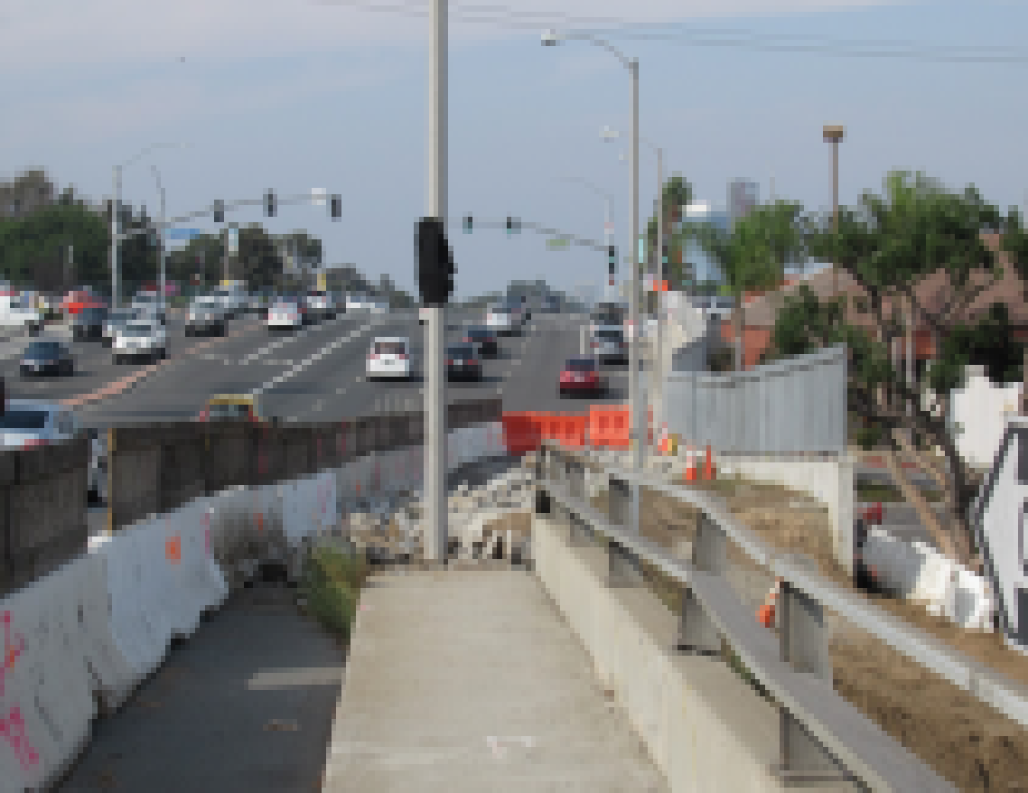
S2 prepared the City’s Quality Assurance Plan that was submitted to Caltrans and approved. All sampling and testing followed the QAP that was based on the testing requried per the standard Specifications and Construction Manual.

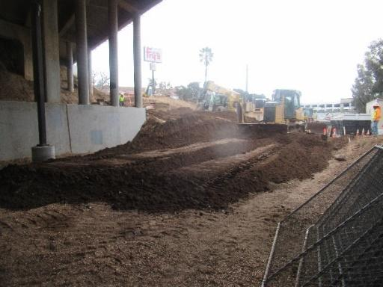

25. FIRMS FROM SECTION C INVOLVED WITH THIS PROJECT
a. | (1) FIRM NAME  S2 Engineering, Inc. |  | (2) FIRM LOCATION (CITY AND STATE)  Rancho Cucamonga, CA |  |  | (3) ROLE  Construction Management, Inspections, and Materials Testing, SIQMP SMR.
STANDARD FORM 330 (REV. 7/2021)

